Module Eight: Activity
Bayyan N Rushdan
Department of Computer Science
Southern New Hampshire University
CS 630 Software Testing and QA
Dr Ben Torrales
August 30, 2026

Module Eight: Activity
Configuring a CI Server
The purpose of this activity was to configure Jenkins to automatically test the provided Python triangle API whenever Jenkins detected a committed change in the GitHub repository. The CI process was configured to retrieve the main branch, verify the Python files, start the Flask API, execute the provided pytest test, publish the test results, and display the final build status.
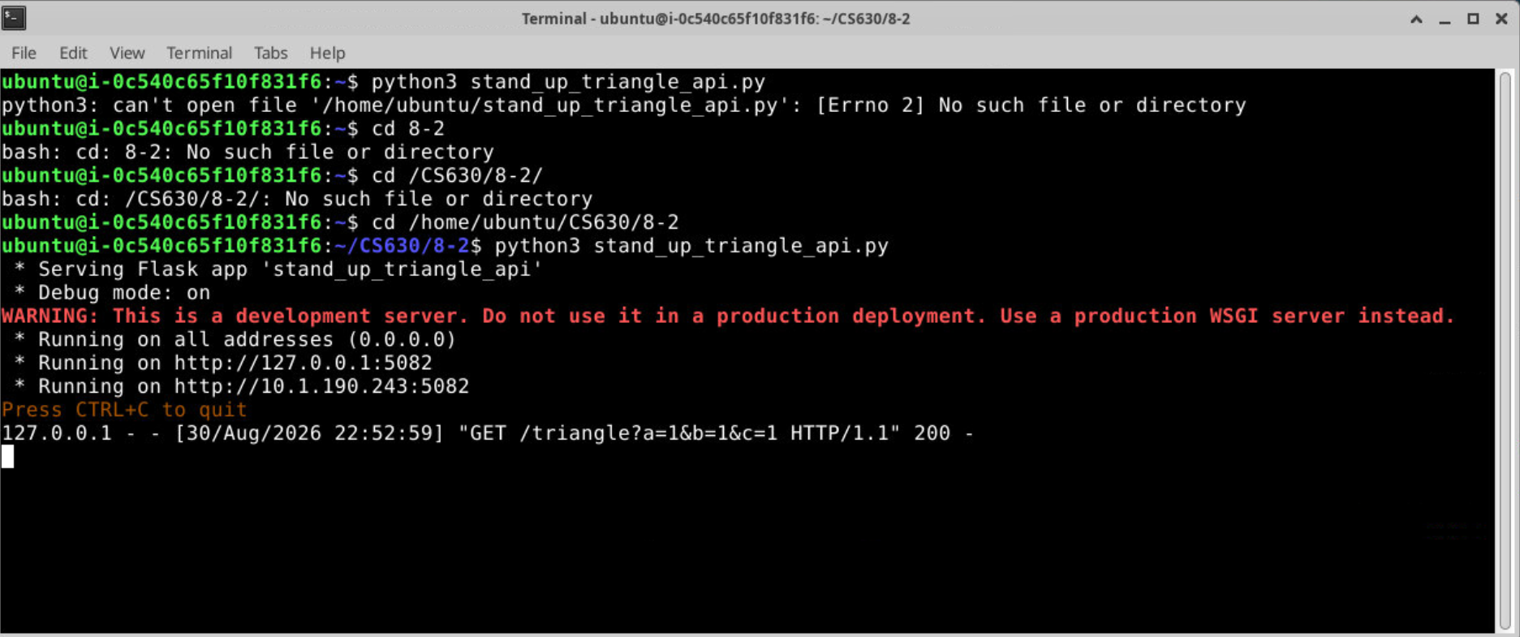
Figure 1: Running Test Program API
The triangle API was started from the 8-2 project directory and made available locally on port 5082. This service had to remain active while pytest sent a request to the triangle endpoint.
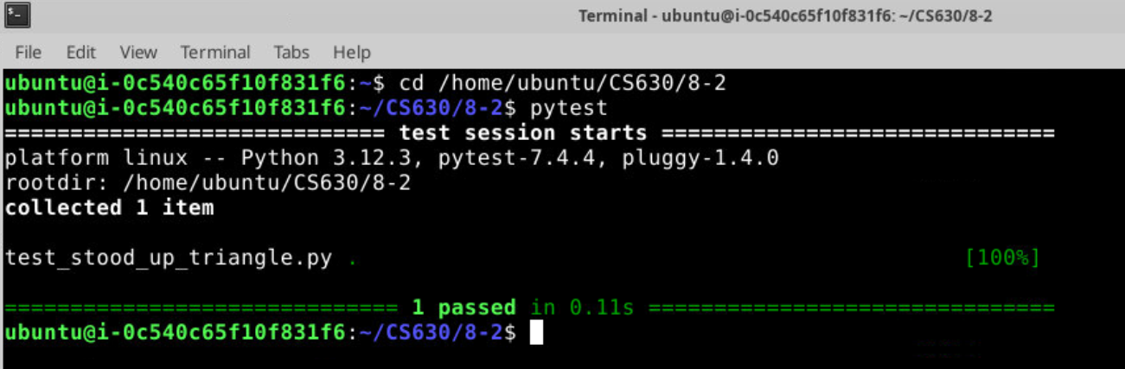
Figure 2: pytest
Before configuring Jenkins, I manually ran the provided test to confirm that the Python project and API functioned correctly. Pytest collected one test and successfully passed test_get_equilateral, establishing a working baseline for the Jenkins build.
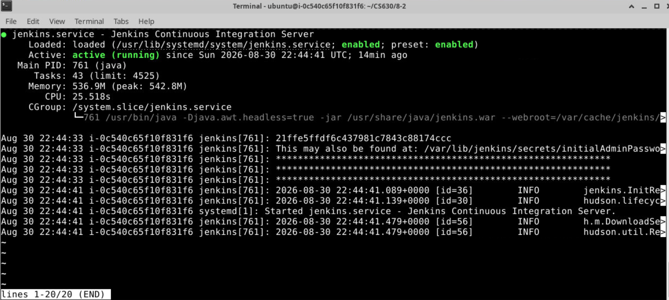Figure 3: Jenkins File Access Verification
An initial Jenkins build failed because the Jenkins service account could not access the project files in the local Ubuntu directory. After verifying and correcting the directory permissions, I followed the Git-based option in the student guide and forked the provided repository into my own GitHub account. This allowed Jenkins to retrieve the project in its own workspace and enabled me to make commits that Jenkins could detect automatically through SCM polling.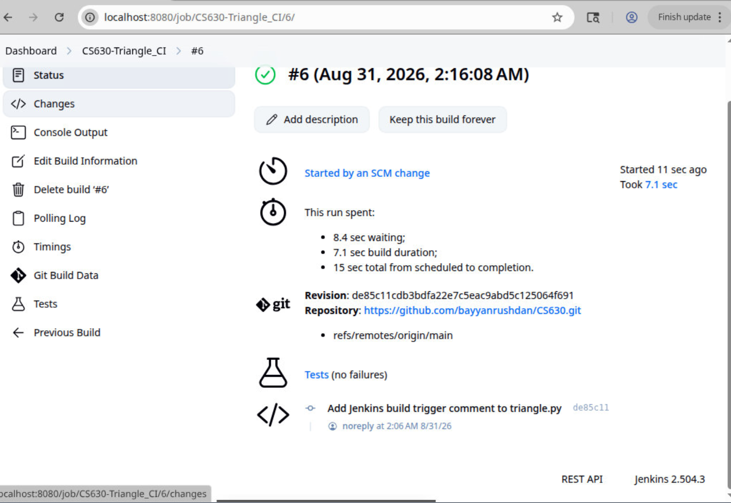
Figure 4: SCM Change
Jenkins was configured to poll the main branch of my forked GitHub repository approximately every two minutes. After I committed a comment to triangle.py, Jenkins detected the source-control change and automatically started build #6. The build completed successfully and displayed no test failures.
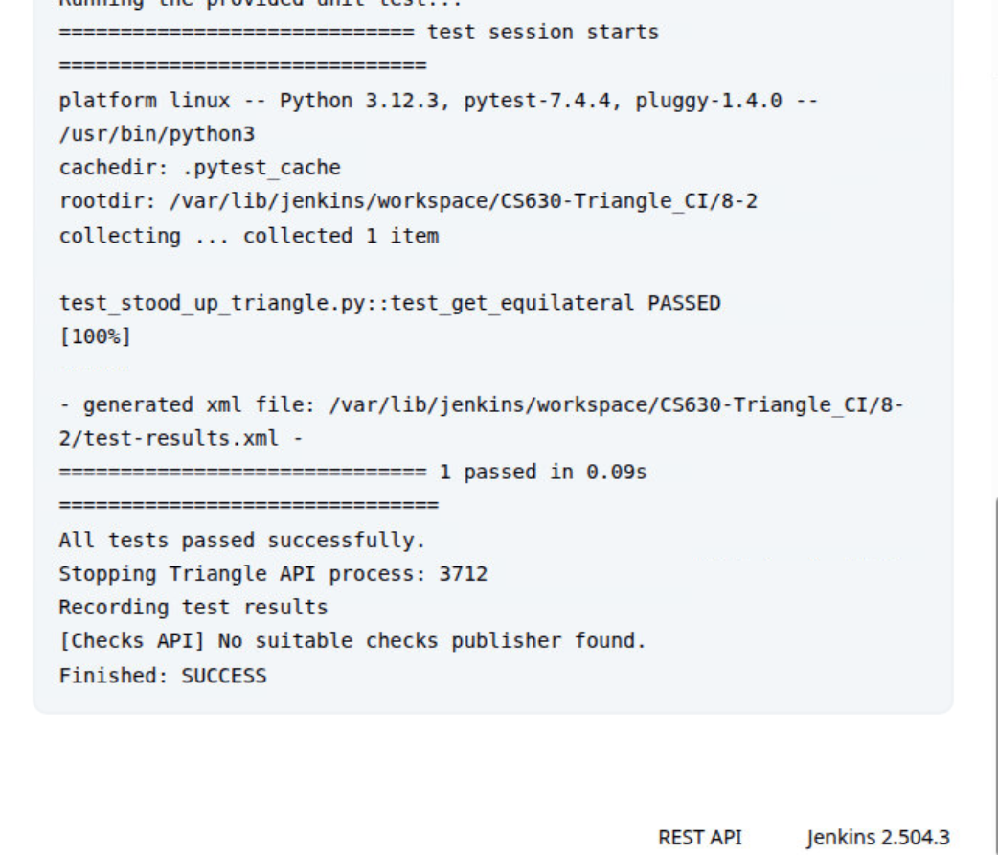Figure 5: Console Output
The console output provides readable and actionable feedback about the build. It identifies the executed test, shows that test_get_equilateral passed, reports that one test completed successfully, confirms that the JUnit XML report was generated, and ends with Finished: SUCCESS.
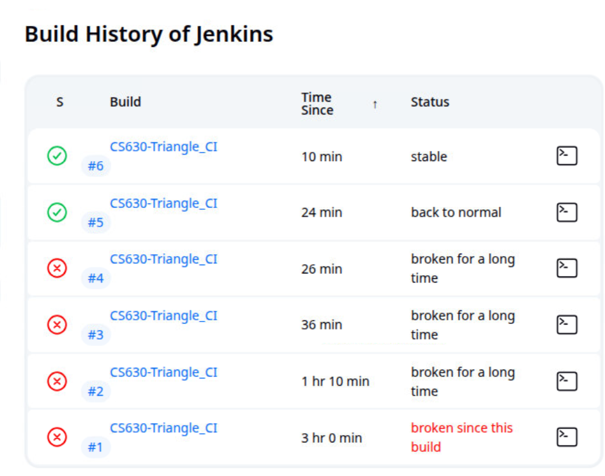Figure 6: Build History
The build history documents the process of resolving the Jenkins configuration errors. Builds #1 through #4 failed because of directory permissions, generated-file permissions, and an incorrect JUnit report path. After these issues were corrected, build #5 returned the job to normal and build #6 remained stable. These consecutive successful builds demonstrate that the CI process is repeatable.

Appendix A: Jenkins Configuration File
The following config.xml file contains the complete Jenkins job configuration, including the GitHub repository, main branch, SCM polling schedule, shell build commands, and JUnit test-result publisher.
<?xml version='1.1' encoding='UTF-8'?>
<project>
<actions/>
<description/>
<keepDependencies>false</keepDependencies>
<properties/>
<scm class="hudson.plugins.git.GitSCM" plugin="git@5.10.1">
<configVersion>2</configVersion>
<userRemoteConfigs>
<hudson.plugins.git.UserRemoteConfig>
<url>https://github.com/bayyanrushdan/CS630.git</url>
</hudson.plugins.git.UserRemoteConfig>
</userRemoteConfigs>
<branches>
<hudson.plugins.git.BranchSpec>
<name>*/main</name>
</hudson.plugins.git.BranchSpec>
</branches>
<doGenerateSubmoduleConfigurations>false</doGenerateSubmoduleConfigurations>
<submoduleCfg class="empty-list"/>
<extensions/>
</scm>
<canRoam>true</canRoam>
<disabled>false</disabled>
<blockBuildWhenDownstreamBuilding>false</blockBuildWhenDownstreamBuilding>
<blockBuildWhenUpstreamBuilding>false</blockBuildWhenUpstreamBuilding>
<triggers>
<hudson.triggers.SCMTrigger>
<spec>H/2 * * * *</spec>
<ignorePostCommitHooks>false</ignorePostCommitHooks>
</hudson.triggers.SCMTrigger>
</triggers>
<concurrentBuild>false</concurrentBuild>
<builders>
<hudson.tasks.Shell>
<command>#!/bin/bash cd "/var/lib/jenkins/workspace/CS630-Triangle_CI/8-2" || exit 1 echo "Working directory:" pwd echo "Checking Python files..." python3 -m compileall -q . echo "Starting Triangle API..." python3 stand_up_triangle_api.py > "/var/lib/jenkins/workspace/CS630-Triangle_CI/8-2/api.log" 2>&1 & API_PID=$! # Always stop the API when the build finishes cleanup() { echo "Stopping Triangle API process: $API_PID" kill "$API_PID" 2>/dev/null || true } trap cleanup EXIT echo "Waiting for the API to start..." sleep 3 echo "Running the provided unit test..." python3 -m pytest -v --junitxml="/var/lib/jenkins/workspace/CS630-Triangle_CI/8-2/test-results.xml" TEST_STATUS=$? if [ "$TEST_STATUS" -eq 0 ]; then echo "All tests passed successfully." else echo "One or more tests failed." echo "API output:" cat "/var/lib/jenkins/workspace/CS630-Triangle_CI/8-2/api.log" fi exit "$TEST_STATUS"</command>
<configuredLocalRules/>
</hudson.tasks.Shell>
</builders>
<publishers>
<hudson.tasks.junit.JUnitResultArchiver plugin="junit@1369.v15da_00283f06">
<testResults>8-2/test-results.xml</testResults>
<stdioRetention>NONE</stdioRetention>
<keepProperties>false</keepProperties>
<keepTestNames>false</keepTestNames>
<healthScaleFactor>1.0</healthScaleFactor>
<allowEmptyResults>false</allowEmptyResults>
<skipPublishingChecks>false</skipPublishingChecks>
<checksName/>
<skipMarkingBuildUnstable>false</skipMarkingBuildUnstable>
<skipOldReports>false</skipOldReports>
</hudson.tasks.junit.JUnitResultArchiver>
</publishers>
<buildWrappers/>
</project>

